**Notice of non-commissioned work**

**Example PSA in previous prostate cancer diagnosis**

1. Run S1 search for patients with prostate cancer (the Ardens report below is linked to the Patient Status Alert for Prostate Cancer). **Note**: you only need to view Current Patients (see breakdown options below).



This is the search criteria:

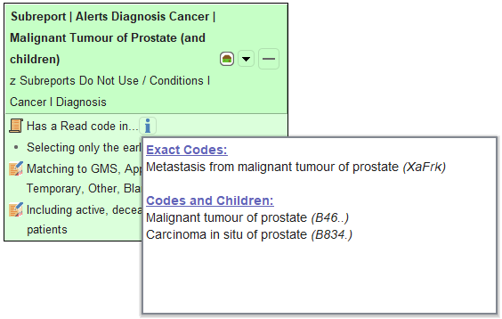

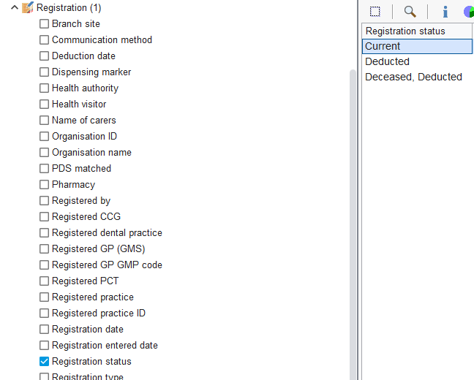

Other useful Ardens Searches for Prostate Cancer

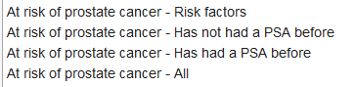

1. Identify which patients have been discharged from secondary care follow up for GP monitoring.
2. Create referral letter using Lincolnshire LMC template letter (Practice Letter to Secondary Care-PSA) to refer to secondary care for monitoring of PSA.



1. Send all relevant referrals via eRS.
2. Create letter for patient to explain referral using LMC template letter (Practice Letter to Patient-PSA).



**Example MGUS (Monoclonal Gammopathy of Undetermined Significance) diagnosis**

1. Run S1 search for patients with MGUS (Monoclonal Gammopathy of Undetermined Significance) (the Ardens report below is linked to the Patient Status Alert for MGUS). **Note**: you only need to view Current Patients (see breakdown options below).



This is the search criteria:

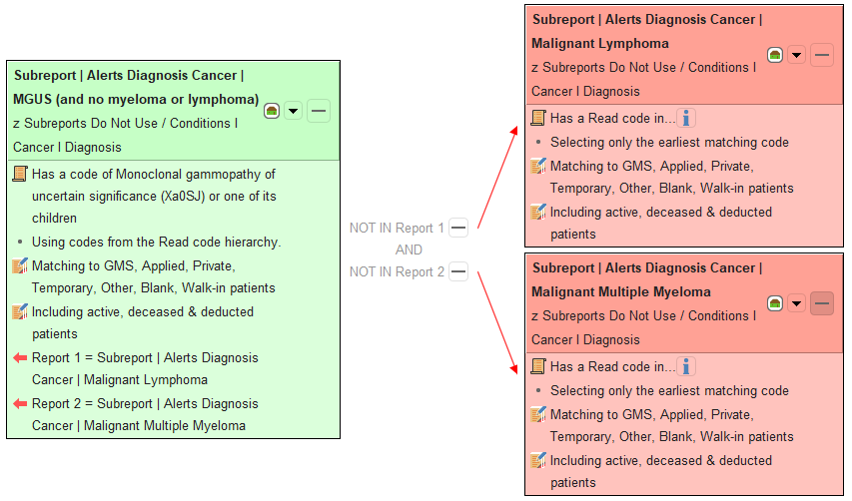



**Other useful Ardens Searches for MGUS**



1. Identify which patients have been discharged from secondary care follow up for GP monitoring.
2. Create referral letter using Lincolnshire LMC template letter (Practice Letter to Secondary Care-MGUS) to refer to secondary care for monitoring of MGUS.



1. Send all relevant referrals via eRS.
2. Create letter for patient to explain referral using LMC template letter (Practice Letter to Patient-MGUS).



**Creating a Word Letter Template**

1. Use this link to a [YouTube video](https://www.youtube.com/watch?v=3BtpE5AIqCw&t=206s) for creating a Word Letter Template or ask SystmOne trainers to assist by emailing them on [agcsu.gpsystemstraining@nhs.net](mailto:agcsu.gpsystemstraining@nhs.net)

Alternatively, you can import the letter from this batch (**note**: this batch contains 4 letters).

1. From SystmOne Menu – Setup – Referrals & Letters – Word Letter Templates



1. Navigate to the file location.

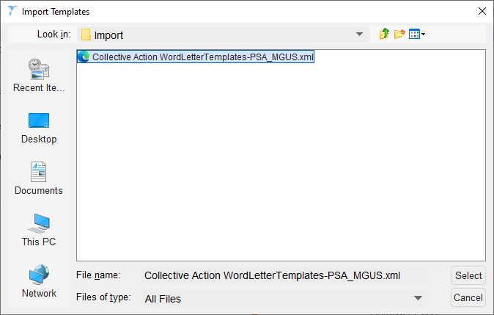



1. Below is the letter we have sent to urology and haematology to inform them of the referrals they will receive.

