**Notice of non-commissioned work**

**Chronic Lymphocytic Leukaemia (CLL)** **diagnosis**

1. Import the following searches created by Lincolnshire LMC (Importing instructions at the end of this document). **Note**: At this time, Arden’s have not provided searches for practices to use, therefore extra care must be taken when looking at the patient record prior to sending letters to patients and the consultant.



1. Run the imported report named: **Chronic Lymphocytic Leukaemia Register** (Located in the BMA Collective Action – Non commissioned folder.

**This is the search criteria:**

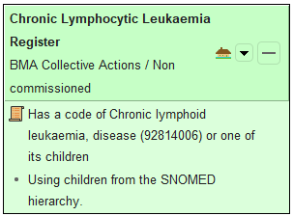

1. Identify which patients have been discharged from secondary care follow up for GP monitoring.
2. Create referral letter using Lincolnshire LMC template letter (Practice Letter to Secondary Care-CLL) to refer to secondary care for monitoring of CLL.



1. Send all relevant referrals via eRS.
2. Create letter for patient to explain referral using LMC template letter (Practice Letter to Patient-CLL).



**Importing Clinical Searches to SystmOne**

1. From the SystmOne Menu select **Reporting** – **Clinical Reporting.**

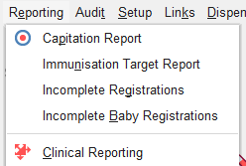

1. Select **Import**.



1. Navigate to the file location (report is in the document above).

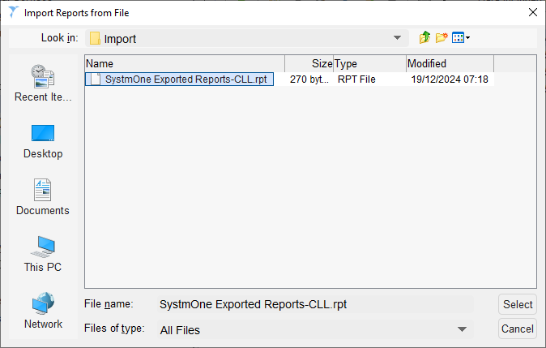

1. Select the file and click **Select**. The search(es) will be imported and stored in the following location unless you choose to store elsewhere.

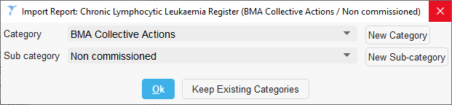

**Creating a Word Letter Template**

1. Use this link to a [YouTube video](https://www.youtube.com/watch?v=3BtpE5AIqCw&t=206s) for creating a Word Letter Template or ask SystmOne trainers to assist by emailing them on [agcsu.gpsystemstraining@nhs.net](mailto:agcsu.gpsystemstraining@nhs.net)

Alternatively, you can import the letter from this batch (**note**: this batch contains 4 letters).

1. From SystmOne Menu – Setup – Referrals & Letters – Word Letter Templates



1. Navigate to the file location.

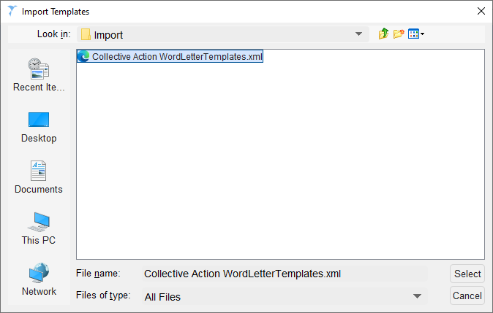



Below is the letter we have sent to haematology to inform them of the referrals they will receive.

