**Notice of non-commissioned work**

**12 Lead ECG provision**

If you are not currently signed up to an enhanced service to provide 12 lead ECG:

1. If patient needs an ECG - create a referral to the Trust ECG service accessible from the Ardens Communications Template i.e. for ULH use the form - Cardiology Investigations Request - ULH

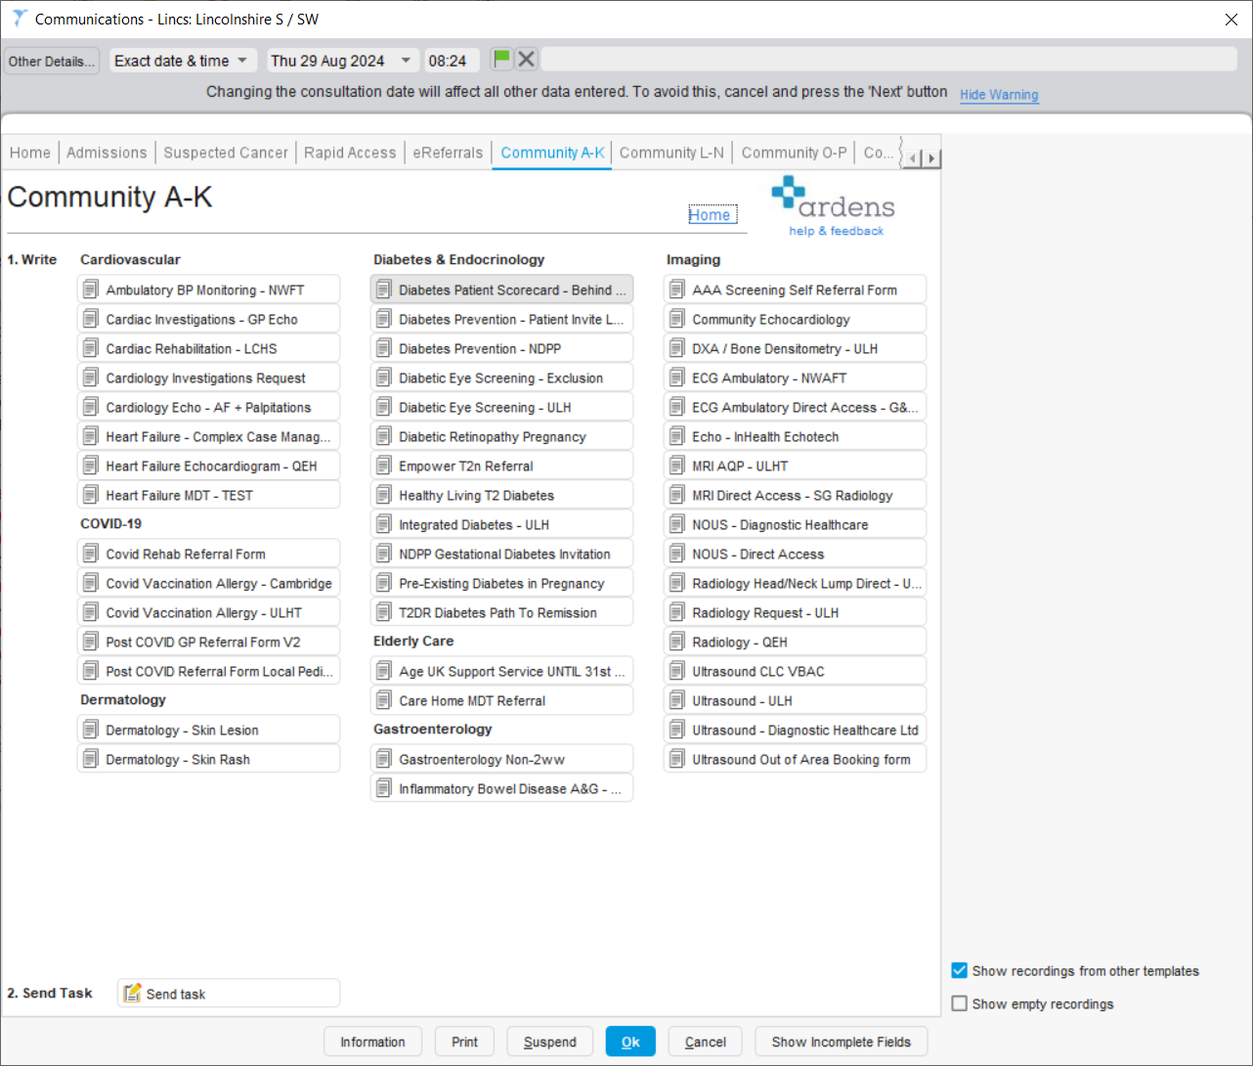

1. If the patient is felt to need an urgent ECG due to the clinical situation, then the disposition should be UTC/ED ideally with letter below.



It is available via the Ardens Communications Template – Other Section (see below), or searchable by typing ‘A&E Referral’ in the search criteria.

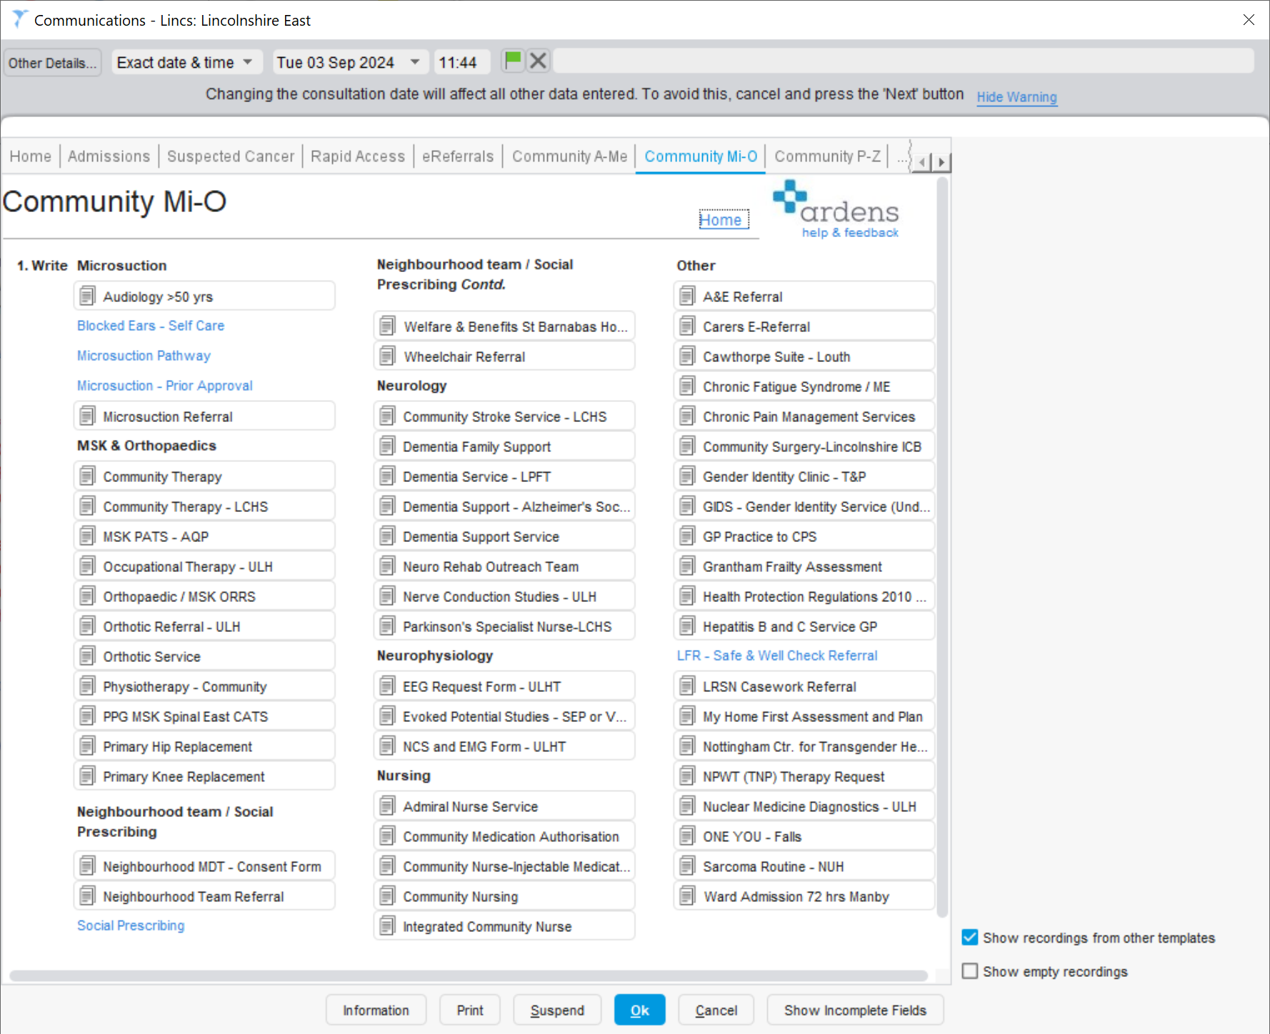

1. If a request is received from secondary care to undertake an ECG for a patient (such as part of OPA or discharge processes, complete the LMC Ardens breech letter to be sent to the provider and ICB so that secondary care can arrange the ECG via trust ECG service.

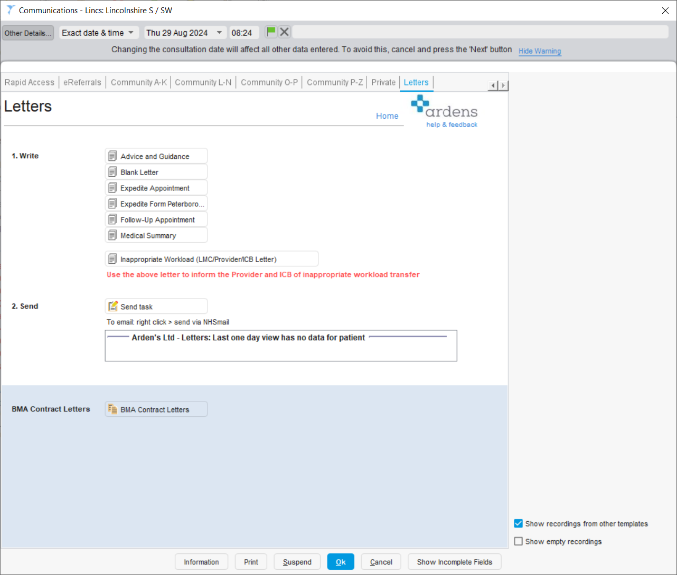

Please see letters below sent by the LMC to Trusts for dissemination to their departments to be aware of this action and their need to amend their processes.

